SYLLABUS

CONCRETE AND HIGHWAY MATERIALS LAB
Instruction : 3 periods / week
Credits : 1.5 Duration : 3 Hours

List of Exercise:
A) Tests on cement and concrete
1. Normal Consistency and setting time of cement.
2. Fineness, Specific gravity and Soundness of cement
3. Compressive strength of cement.
4. Workability test on concrete by compaction factor, slump and Vee-bee.
5. Young’s modulus and compressive strength of concrete.
6. Bulking of sand.
7. Non-Destructive testing on concrete [for demonstration].
B) Tests on Highway Materials
1. Aggregate Crushing value and Impact Test
2. Specific Gravity and Water Absorption.
3. Attrition and Abrasion Test
4. Shape tests
5. Penetration and Softening Point Test on Bitumen.
6. Ductility Test.
7. Flash and fire point tests.
REFERENCES:
Concrete Testing Manual by M.L.Gambhir, Tata McGraw Hill, 2012 New Delhi.
- Highway Material Testing Manual by Justo & Khanna.

1. Normal Consistency and setting time of cement.

Exp No: 1 (a) STANDARD CONSISTENCY OF CEMENT Date:

AIM:
To determine the quantity of water required to produce a cement paste of standard consistency.
DEFNITION:
Standard consistency is defined as that consistency which will permit the Vicat’s plunger to penetrate to a point 5 to 7 mm from the bottom of the Vicat’s mould when the cement is tested.
APPARATUS: 1. Vicat’s apparatus, Mould, Plunger.
2. Standard trowel
3. Stop watch.
4. Weighing balance
DESCRIPTION:

The Vicat’s apparatus consists of a frame and a moving rod weighing 300 gm. A cylindrical plunger of 10 mm diameter is kept at the lower end of the rod. A pointer connected to the rod will move along with it when it is released, over a graduated scale kept in front of it. The cement paste to be tested is kept in the Vicat’s mould kept below the rod on a glass plate.
PROCEDURE:
- Prepare a paste of weighed quantity of cement (400 grams) with a weighed quantity of potable or distilled water, starting with 26% water of 400g of cement.
- Take care that the time of gauging is not less than 3 minutes, not more than 5 minutes and the gauging shall be completed before setting occurs.
- The gauging time shall be counted from the time of adding the water to the dry cement until commencing to fill the mould.
- Fill the vicat mould with this paste, the mould resting upon a non-porous plate.
- After completely filling the mould, trim off the surface of the paste, making it in level with the top of the mould. The mould may slightly be shaken to expel the air.
- Place the test block with the mould, together with the non-porous resting plate, under the rod bearing the plunger (10mm diameter), lower the plunger gently to touch the surface of the test block and quickly release, allowing it to penetrate into the paste.
- This operation shall be carried out immediately after filling the mould.
- Prepare trial pastes with varying percentages of water and test as described above until the amount of water necessary for making the standard consistency as defined above is obtained.
- Express the amount of water as a percentage by weight of the dry cement.
OBSERVATIONS:

 | Weight of | cement | Weight of water | Plunger | Time | Consistency of  cement in %  (b/a)*100
S. No | taken in gms (a) |  | taken in gms (b) | Penetration  (mm)
 |  |  |  |  | Taken

CALCULATIONS:
Weight of cement taken = W₁.
Weight of water added when the plunger has a penetration of
5 to 7 mm from the bottom of the mould = W₂
Percentage of water for standard consistency
p = (W₂ / W₁) x 100
RESULT: Percentage of water for standard consistency is __________________
VIVA VOCE:
  - Define Normal Consistency of cement.
  - What is hydration of cement?
  - What are bogues compounds?
  - What is the maximum time of gauging?

SPECIMEN CALCULATIONS:

Exp No: 1 (b) INITIAL SETTING TIME OF CEMENT Date:

AIM:
To determine the initial and final setting times of cement.
APPARATUS:
The Vicat’s apparatus, Needle, Annular ring, Trays, Balance and Weights.
PROCEDURE:
- Preparation of Test Block: Prepare a neat cement paste by gauging the cement with 0.85 times the water required to give the paste of standard consistency. Start a stopwatch at the instant when water is added to the cement. Fill the Vicat’smould with a cement paste with in three to five minutes after addition of water. Fill the mould completely and smooth off the surface of this paste making it level with the top of the mould. The cement block thus prepared in the mould is test block.
- Clean appliances shall be used for gauging. The temperature of water and that of the test room at the time of gauging shall be within (27 ±2 )⁰C.
- During the test the block shall be kept at a temperature of (27 ± 2)⁰C and at least 90% relative humidity.
A) DETERMINATION OF INITIAL SETTING TIME:
Place the test block confined in the mould and resting on the nonporous plate, under the rod bearing the needle, lower the needle gently in contact with the surface of the test block and quickly release, allowing it to penetrate into the test block. In the beginning the needle will completely pierce the test block. Repeat this procedure until the needle, when brought in contact with the test block and released as described above, fails to pierce the block for 5 to 7 mm measured from the bottom of the mould. The period elapsing between the time when water is added to the cement and this time shall be initial setting time.
B) DETERMINATION OF FINAL SETTING TIME:
Replace the needle of the Vicat’s apparatus with the needle with an circular attachment. The cement shall be considered as finally set, when upon lowering the needle gently to the surface of the test block the needle makes an impression there on, while the attachment fails to do so. In other words the paste has attained such hardness that the centre needle does not pierce through the paste more than 0.5mm.
The period elapsing between the time when water is added to the cement and the time at which the needle makes an impression on the surface on the test block while the attachment fails to do so shall be the final setting time.
OBSERVATIONS:
INITIAL SETTING TIME:
S. No. | Time | Reading on the scale of Vicat’s apparatus
FINAL SETTING TIME:
S. No. | Time | Reading on the scale of Vicat’s apparatus

RESULT:
Initial setting time of the cement =
Final setting time of the cement =
SPECIFICATION:
As per I.S.: 269 – 1989 the initial setting time should not be less than 30 minutes and final setting time should not be more than 600 minutes for ordinary Portland cement.
VIVA VOCE:
  - What is meant by setting of cement?
  - Define intial and final setting times of cement.
  - What is the percentage of water added to prepare the cement paste?
  - What is heat of hydration?
  - What are the standard specifications of intial and final setting times of cement as per I.S code?
SPECIMEN CALCULATIONS:

2.Fineness, Specific gravity and Soundness of cement
Exp No: 2(a) DETERMINATION OF FINENESS OF CEMENT
(IS: 4031 – part – 3) Date:

OBJECT:
To determine the fineness of cement by dry sieving.
APPARATUS:
- Standard balance with 100 gm. Weighing capacity.
- IS: 90 micron sieve confirming to IS: 460-and a Brush.
PROCEDURE:
- Break down any air-set lumps in the cement sample with fingers.
- Weigh accurately 100 g of cement and place it on a standard 90 micron IS sieve.
- Break down any air-set lumps in the cement sample with fingers.
- Continuously sieve the sample giving circular and vertical motion for a period of 15 minutes.
- Weigh the residue left on the sieve. As per IS code the percentage residue should not exceed 10%.

RESULT:
The percentage weight of residue over the total sample is reported
% Weight of Residue = 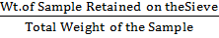
LIMITS:
The percentage residue should not exceed 10%.

PRECAUTIONS:
Sieving shall be done holding the sieve in both hands and gentle wrist motion. This will involve no danger of spilling the cement. Which shall be kept well spread out on the screen. More or less continuous rotation of the sieve shall be carried out throughout sieving.
Washers, shots and slugs shall not be used on the sieve. The underside of the sieve shall be lightly brushed with a 25 or 40 mm bristle brush after every five minutes of sieving.
Mechanical sieving devices may be used, but the cement shall not be rejected if it meets the fineness requirement when tested by the hand method.

VIVA VOCE:
  - Define Fineness.
  - What are the steps involved in field test of cement?
  - What is maximum acceptable limit of percentage of fineness of cement?
  - What are the different grades of cement?
  - What is the chemical composition of cement?

SPECIMEN CALCULATIONS:

Exp No: 2 (b) SPECIFIC GRAVITY OF CEMENT Date:

REF: I.S 4031 - 1988

AIM:
To determine the specific gravity of cement

DEFINITION:
Specific gravity of cement is defined as the ratio of weight of a given volume of cement at a given temperature to the weight of an equal volume of distilled water at the same temperature both weights being taken in air.

APPARATUS:
Specific gravity bottle, weighing balance

MATERIAL:
Kerosene free of water, naphtha having a specific gravity not less than 0.7313 shall be used in the specific gravity determination.

PROCEDURE:
- Clean and dry the specific gravity bottle and weigh it with the stopper (W1).
- Fill the specific gravity bottle with cement sample at least half of the bottle and weigh with stopper (W2).

- Fill the specific gravity bottle containing the cement, with kerosene (free of water) placing the stopper and weigh it (W3).
- While doing the above do not allow any air bubbles to remain in the specific gravity bottle.

- After weighing the bottle, the bottle shall be cleaned and dried again.
- Then fill it with fresh kerosene and weigh it with stopper (W4).
- Remove the kerosene from the bottle and fill it with full of water and weigh it with stopper (W5).

- All the above weighing should be done at the room temperature of 27c + 1⁰c.

OBSERVATIONS:

- Wt. of empty dry specific gravity bottle = W₁
- Wt. of bottle + Cement (filled 1/4 to 1/3 ) = W₂
- Wt. of bottle + Cement (Partly filled ) + Kerosene = W₃
- Wt. of bottle + Kerosene (full). = W₄
- Wt. of bottle + water (full) = W₅

Specific gravity of kerosene S_{k} = (W₄ – W₁) / (W₅ – W₁)

(W₂ –W₁) x S_{k}
Specific gravity of Cement = ---------------------------
(W₄ – W₁) – (W₃ – W₂)

RESULT: Specific Gravity of cement =

VIVA VOCE:
  - Define Specific gravity of cement.
  - What is the reason for adding kerosene to the specific gravity bottle. Why not anyother fluid?

SPECIMEN CALCULATIONS:

Exp No: 2 (c) SOUNDNESS OF CEMENT (IS 269-1989, IS 4031-1988 PART 3) Date:
AIM:
To determine the soundness of the given sample of cement by "Le Chatelier" Method.

APPARATUS:
Le Chatelier apparatus conforming to IS 5514-1969, Balance, Weights,
Water bath.

INTRODUCTION:
It is essential that the cement concrete shall not undergo appreciable change in volume after setting. This is ensured by limiting the quantities of free lime, magnesia and sulphates in cement which are the causes of the change in volume known as unsoundness. Unsoundness in cement does not come to surface for a considerable period of time. This test is designed to accelerate the slaking process by the application of heat and discovering the defects in a short time. Unsoundness produces cracks, distortion and disintegration there by giving passage to water and atmospheric gases which may have injurious effects on concrete and reinforcement.

The apparatus for conducting the test consists of small split cylinder of spring brass or other suitable metal of 0.5mm thickness forming a mould 30 mm internal diameter and 30mm high. On either side of the split mould are attached to indicators with pointed ends, the distance from these ends to the center of the cylinder being 165 mm. The mould shall be kept in good condition with the jaws not more than 50mm apart.

PROCEDURE:

- Place the lightly oiled mould on a lightly oiled glass sheet and fill it with cement paste formed by gauging cement with 0.78 times the water required to give a paste of standard consistency.

- The paste shall be gauged in the manner and under the conditions prescribed in determination of consistency of standard cement paste, taking care to keep the edges of the mould gently together

- While this operation is being performed cover the mould with another piece of glass sheet, place a small weight on this covering glass sheet and immediately submerge the whole assembly in water at a temperature of 27 ⁰ - 2⁰ C and keep there for 24 hours.
- Measure the distance separating the indicator points.
- Submerge the moulds again in water at the temperature prescribed above.
- Bring the water to boiling, with the mould kept submerged for 25 to 30 minutes, and keep it boiling for three hours.

- Remove the mould from the water allow it to cool and measure the distance between the indicator points.

- The difference between these two measurements represents the expansion of the cement.

- For good quality cement this expansion should not be more than 10mm.

OBSERVATIONS:

Initial distance between the indicator points in mm =
Final distance between the indicator points in mm - Expansion in mm =
final length - initial length =

RESULT: Expansion in mm _________

VIVA VOCE:
  - Define Soundness of cement.
  - What is the percentage of water added in this experiment to prepare the cement paste?
  - What are the causes of Unsoundeness of cement?
  - What is the maximum limiot of expansion of a sound cement?
  - What is Autoclave method?

SPECIMEN CALCULATIONS:

3. COMPRESSIVE STRENGTH OF CEMENT

Exp No: 3 COMPRESSIVE STRENGTH OF CEMENT Date:

AIM:
To find the compressive strength of given sample of cement.
APPARATUS:
7.07cm cube moulds (50cm² c/s area), compression testing machine, vibrating machine, Balance, Weights and Trays.
PROCEDURE:
Measure the given cement and standard sand in the proportion 1:3 by weight.
- Standard sand: It shall pass the 850 micron I.S. sieve and not more than 10% by weight shall pass the 600 micron I.S. sieve. Take 200 gms of cement and 600 gms of standard sand in a pan. Mix it dry with a trowel for one minute and then add water. The quantity of water shall be (0.25 P + 3) percent of combined weight of cement and sand, where P is the % of water required to produce a paste of standard consistency determined earlier. Add water and mix it until the mixture is of uniform colour. The time of mixing shall not be less than 3 minutes and not greater than 4 minutes.
- Immediately after mixing the mortar place the mortar in the cube mould and tamp with the help of the tamping rod. The mortar shall be rodded 20 times in about 8 seconds to ensure elimination of entrained air.
- If vibrator is used the period of vibration shall be two minutes at the specified speed of 12000 vibration per minutes.

- Then place the cube moulds in an atmosphere of 27⁰± 2⁰c and 90% relative humidity, submerge in clear fresh water till testing.

- Take out the cubes from water just before testing. Testing should be done on their sides with out any packing. The rate of loading should be uniform and of 350kg/cm²/minute.

- Three cubes should be tested and their average should be taken as the test result. Report the result in Kg/cm².
OBSERVATIONS: Compressive load at three days =
Compressive load at seven days =
RESULT: Compressive strength of cement at three days =
Compressive strength of cement at seven days =
I.S. Specification: For ordinary Portland cement of grade 33 the crushing strength shall not be less then 16 MPa at 3 days, 22 MPa at 7 days and 33 MPa at 28 days.
VIVA VOCE:
  - What does 33 stand for in a 33grade cement?
  - What is the standard sand used for preparing cement mortar?
  - Why cement mortar is used instead of cement paste for determining the compressive strength of cement?
  - What is the percentage of water added to prepare the cement mortar?
SPECIMEN CALCULATIONS:

4. WORKABILITY TEST ON CONCRETE BY COMPACTION FACTOR, SLUMP AND VEE-BEE.

Exp No: 4 (a) WORAKABILITY OF CONCRETE – SLUMP TEST Date:

AIM:
To determine the workability of concrete mix of given proportion by slump test.
APPARATUS:
Iron pan to mix concrete, weighing machine, trowel, slump cone, scale and tamping rod.
DESCRIPTION:
The slump cone is a hollow frustum made of thin steel sheet with internal dimensions as, the top diameter 10 cm, the bottom diameter 20 cm, and height 30 cm .It stands on a plane non- porous surface. To facilitate vertical lifting from molded concrete it is provided with a suitable guide attachment and suitable foot places and handles. The tamping rod is 16 mm dia 60 cm long and is bullet pointed at the lower end.

THEORY:
Unsupported concrete, when it is fresh, will flow to the sides and a sinking in height will take place. This vertical settlement is called slump. Slump is a measure indicating the workability of cement concrete and also slump gives an idea of W/C ratio needed for concrete to be used for different works. Slump increases with W/C ratio. A concrete is said to be workable if it can be easily mixed and easily placed compacted and easily finished.

PROCEDURE:
Mixes are prepared with W/C. ratio 0.4, 0.5, 0.55 and 0.6. For each mix take C.A. = 10 kg, F.A. = 5 kg and Cement = 2.5 kg.
- Mix the dry constituents to get an uniform color and then add water.
- The internal surface of the mould is to be thoroughly cleaned and place on a smooth, horizontal, rigid and non-absorbent surface.
- Place the mixed concrete in the cleaned slump cone in 4 layers each approximately ¼ in height of the mould . Tamp each layer 25 times with tamping rod.
- Remove the cone immediately, rising it slowly and carefully in the vertical direction.
- As soon as the concrete settlement comes to a stop, measure the ubsidence of the concrete in mm, which gives the slump.
OBSERVATIONS:
S. No. | W/C Ratio | Slump | Type of Slump
1 | 0.45
2 | 0.5
3 | 0.55
4 | 0.6
5 | 0.65
RESULT:

SPECIFICATIONS:
As per I.S: 456 the degree of workability is classified as follows.
Degree of workability Slump(mm)
Very low 0 to 25
Low 25 to 50
Medium 50 to 100
High 100 to 175
VIVA VOCE:
  - Define Workability of Concrete?
  - What is true slump of concrete?
  - What is shear slump?
  - What is the effect of W/C ratio on workability of concrte?
SPECIMEN CALCULATIONS:

Exp No: 4 (B) WORKABILITY OF CONCRETE BY COMPACTING FACTOR TEST Date:

AIM:
To determine the workability of concrete mix of given proportions by compacting factor test.

APPARATUS:
Compacting factor apparatus, Balance, Weights, Trays, Tamping rod and Trowels.

DESCRIPTION:
Compacting factor apparatus consists of two conical hoppers mounted above a cylindrical mould and fixed to a stand one above the other. The hoppers are provided with trap doors at the bottom. The dimensions of various parts are given below.
1. Upper Hopper Dimensions in cm.
Top internal dia. 25.4
Bottom 12.7
Internal height 27.9
- Lower Hopper Dimension in cm.
Top internal dia. 22.9
Bottom 12.7
Internal height 22.9
- Cylinder Dimension in cm.
Internal Diameter 15.2
Internal Height 30.5

Distance between bottom of upper hopper and top of lower hopper is 20.3 cm. Distance between bottom of lower hopper and top of cylinder is 20.3 cm.

DEFINITION:
Compacting factor is defined as the ratio of weight of partially compacted concrete to the weight of fully compacted concrete.

PROCEDURE:
Four mixes are prepared with W/C., ratios 0.4, 0.5, 0.55, 0.6 and 0.65. For each mix take 2.5 kg of cement, 5 kg of fine aggregate and 10 kg of coarse aggregate.

- Mix the dry constituents to get an uniform color and then add water.
- The internal surfaces of the hoppers and cylinder are thoroughly cleaned.
- The sample of concrete to be tested is placed gently in the upper hopper.
- The hopper is filled level with its brim and the trap door is opened so that the concrete falls into the lower hopper.
- If concrete has a tendency to stick to the sides of the hopper, the concrete should be slowly pushed down by inserting the tamping rod into the concrete.
- Immediately after the concrete comes to door of the lower hopper, it is opened and the concrete is allowed to fall into the cylinder.
- The excess of concrete in the cylinder above the top is cut off and made level with trowels. The outside of cylinder is wiped clean.
- The weight of the concrete in the cylinder is then determined. This weight is known as weight of partially compacted concrete.
- The cylinder is refilled with concrete from the same sample in six layers and each is rammed thoroughly.
- The top of fully compacted concrete should be carefully struck off level with top cylinder. The outside of the cylinder is wiped a clean and the weight of fully compacted concrete is found.

OBSERVATIONS:
S. No. | W/C | W₁ | W₂ | W₂–W₁ | W₃ | W₃–W₁ | C.F. =(W₂–W₁ / W₃–W₁)

CALCULATIONS:
Weight of cylinder W₁ =
Weight of cylinder + partially compacted W₂ =
Weight of Partially compacted concrete (W₂-W₁) =
Weight of cylinder + fully compacted concrete W₃ =
Weight of fully compacted concrete (W₃-W₁) =
Compacting factor (W₂-W₁) / (W₃-W₁). =
RESULTS:
Maximum workability of concrete is occurring at a water / cement ratio of ____________

SPECIFICATIONS:

According to IS 456, the degree of workability in classified as follows:

Degree of workability Compacting factor.
Very Low 0.75 to 0.8
Low 0.8 to 0.85
Medium 0.85 to 0.92
High 0.92 & above.
GRAPH:
A graph is drawn with water / cement ratio on x-axis and values of compaction factor on y-axis.

VIVA VOCE:
  - Define Compacting factor of Concrete.
  - As compacting factor increases the workability of concrete____________.
  - What is meant by seggregation of concrete.
  - What are the standard specifications of compacting factor of concrete as per I.S code?
  - What is meant by partially compacted concrete?
SPECIMEN CALCULATIONS:

Exp No: 4 (c) WORKABILITY OF CONCRETE – VEE BEE TEST Date:

AIM:
To find workability of concrete by Vee-Bee consistency test in terms of Vee Bee Seconds
APPARATUS:
Vee Bee consistometer, Stopwatch, Balance, Tray, Tamping rod, Measuring jar, Weights and Trowels.
THEORY:
The consistometer is used for determining the consistency of concrete by vibrating and transforming a concrete specimen from the shape of conical frustum into a cylinder.
DESCRIPTION:
The consistometer consists of a
- A vibrator table, which vibrates a rate of 3000 vibrations / min.
- A metal pot, which holds the specimen when the concrete is vibrated. It is secured to the vibrator table by bolts.
- Slump cone of 300 mm high, 200 mm at the bottom and 100 mm at the top (Open both ends).
- Swivel arm holder: A tube, which is fixed the rear of the base of the vibrator table. It has 4 positioning slots for swivel arm to position the metal cone over the slump cone or Perspex disc on the specimen or to position both of them away.
- Swivel arms the Swivel moves freely inside the swivel arm holder. A metal rod and a guide sleeve are fixed to the swivel arm. The graduated metal rod passes through the guide sleeve.
- Metal cone - this is in the form of a frustum of cone with open ends (funnel). This is fixed to the swivel arm
- Graduated rod
- Tamping rod. A metal rod of 16 mm x 60 cm. long with one end bullet ended..

PROCEDURE:
- Position the metal cone over the slump cone. Place the concrete inside the slump cone in 4 layers each approximately 1/4 of the height. Strokes are applied by the rounded end of the tamping rod. Distribute the strokes in a uniform manner over the cross section.
- After the top layer has been rodded, position the metal cone of the swivel arm away, and strike off the concrete, level with the top of the cone using a trowel so that the mould is exactly filled.
- Remove any material spilled inside the metal pot or sticking on to the side of the slump filled.
- Position the Perspex disc over the cone and note down the reading on the graduated rod (L₁). After keeping the disc away, lift the slump cone vertically and remove.
- Position the disc over the concrete. Note down the reading of the graduated rod (L₂). The difference in the readings gives the slump in Centimeters.
- Switch on the vibrator starting a stopwatch simultaneously. Allow the concrete to spread out in the pot. When the whole concrete surface uniformly adheres to the Perspex disc, stop the watch, simultaneously, switch off the vibrator. Note down the time in seconds. Also note the reading on the graduated rod (L₃).
- The consistency of the concrete is expressed in Vee-Bee degrees which are equal to the time in seconds.
- Repeat the procedure of different W/C ratios viz.: 0.4, 0.5, 0.55, 0.6 & 0.65.
- Draw a graph between slump in centimeters and Vee – Bee Degrees.
- Knowing the dia of the disc and the height of the concrete after Vibration (30+ L₁ – L₃), the Volume of the concrete can be computed.
OBSERVATIONS:
S. No. | W/C Ratio | Slump (mm) | Vee–Bee Seconds
RESULT:

VIVA VOCE:
  - Define Vee Bee degree.
  - As the Vee bee seconds increases, the workability of concrete____________
  - What are the different tests conducted for determining the workability of Concrete?
  - What is meant by bleeding of concrete?

SPECIMEN CALCULATIONS:

5. YOUNG’S MODULUS AND COMPRESSIVE STRENGTH OF CONCRETE.

Exp No: 5 (a) TEST FOR DETERMINATION OF YOUNG’S MODULUS OF CONCRETE Date:

AIM:
To determine the young’s modulus of given concrete cylindrical specimen of any age.
APPARATUS:
ACTM with axial strain attachment, Scale.
THEORY:
In the elastic theory young’s modulus of the material is defined as proportionality constant which is equal to the ratio of strain to stress. However behavior of concrete under compressive loading is very complex and concrete behaves elastically at very low strain values. Since the concrete gains strength with age, the modulus of elasticity of the concrete also increases with the age of concrete. Therefore young’s modulus is defined as Initial Tangent modulus, Tangent modulus and secant modulus. Initial tangent modulus can be determined by drawing tangent to the obtained stress strain curve at the origin. Tangent modulus can be obtained by drawing tangent to obtained curve at any other required point. Secant modulus can be obtained by drawing a line joining the required point on the curve to the origin. According to IS: 456-2000 value of Young’s modulus can be taken as 5000x√f_{ck} where f_{ck} is defined as the characteristic compressive strength of concrete at the age of 28 days.
PROCEDURE:
1. Take the cylindrical specimen and measure its height at three different locations and obtain the average height.
2. Similarly measure the diameter of the cylinder at both ends.
3. Place the cylindrical specimen in the ACTM and connect strain gauges of the axial strain attachment to the specimen.
4. Obtain the strain gauge reading at every 10 kN loading.
5. Calculate the strains and stresses at every interval of loading.
6. Plot the stress - strain curve and determine Initial Tangent Modulus, Tangent Modulus and Secant Modulus.

OBSERVATIONS:
S.No. | Load in kN | Strain Gauge readings | Stress in MPa | Strain in mm

CALCULATIONS:
(i) Initial Tangent Modulus = Y_{i} / X_{i} where X_{i} and Y_{i} are the coordinates of any point P_{i} on the tangent drawn through the origin.
(ii) Tangent modulus = Y_{t} / X_{t} where X_{t} and Y_{t} are the coordinates of any point P_{t} on any tangent drawn on the curve.
(iii) Secant Modulus = Y_{s} / X_{s} where X_{s} and Y_{s} are the coordinates of any point P_{s} on the line joining the origin and the specified point P_{s}.
RESULT:
- Initial Tangent Modulus = ___________________________ N/mm²
- Tangent Modulus = ___________________________ N/mm²
- Secant Modulus = ___________________________ N/mm²
NOTE:
If analogue or digital compression testing machine is used for conducting experiment, use longitudinal extensometer for strain measurement.
VIVA VOCE:
  - Define Young's modulus.
  - What are the different modulli of Concrete?
  - What is the purpose of using extensometer?
  - What is relationship between Young's modulus and Rigidity modulus?
  - What is the relationship between Young's modulus and bulk modulus?

SPECIMEN CALCULATIONS:

Exp No: 5 (b) COMPRESSIVE STRENGTH OF CONCRETE Date:

AIM:
To determine the compressive strength of concrete.
APPARATUS:
Compression testing machine, Cube moulds of 150mmX150mmX150 mm and cylindrical moulds of 150 mm diameter and 300 mm height, weighing balance.
PROCEDURE:
(i) Cast the cubes and cylinders and cure for 28 days.
(ii) Takeout the specimens from the curing tank.
(iii) Wipe out the excess water from the surface of specimen.
(iv) Place the specimen vertically on the platform of compression testing machine.
(v) Apply the load continuously and uniformly without shock at the rate of 315 kn/min. And continue the loading until the specimen fails.
(vi) Record the maximum load taken.
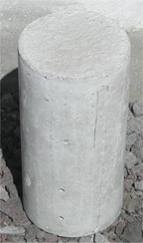
NOTE
Test at least 3 specimens each for cubes and cylinders.

REPORT:
Date of casting :
Date of testing :
Age of specimen :
Curing condition :

CALCULATIONS
Area of cross section of cylinder = LX B =
Area of cross section of cylinder = πd²/4
COMPRESSIVE STRENGTH:
Cube:
Maximum load =
Compressive strength = (Maximum load/ Cross sectional area) =
Cylinder:
Maximum load =
Compressive strength = (Maximum load/ Cross sectional area) =81
RESULT:
Compressive strength of cube =…………………….N/mm²
Compressive strength of cylinder =…………………….N/mm²

VIVA VOCE:
  - Define Poissons ratio.
  - What is the range of poisonns ratio of Concrete?
  - What is the relationship between cube strength and cylinder strength of Concrete?

SPECIMEN CALCULATIONS:

Exp No: 6 (a) BULKING OF SAND Date:

AIM:
To ascertain the bulking phenomena of given sample of sand.
APPARATUS:
1000 ml measuring jar, brush.
INTRODUCTION:
Increase in volume of sand due to presence of moisture is known as bulking of sand. Bulking is due to the formation of thin film of water around the sand grains and the interlocking of air in between the sand grains and the film of water. When more water is added sand particles get submerged and volume again becomes equal to dry volume of sand. To compensate the bulking effect extra sand is added in the concrete so that the ratio of coarse to fine aggregate will not change from the specified value. Maximum increase in volume may be 20 % to 40 % when moisture content is 5 % to 10 % by weight. Fine sands show greater percentage of bulking than coarse sands with equal percentage of moisture.
PROCEDURE:

- Take 1000 ml measuring jar.
- Fill it with loose dry sand upto 500 ml without tamping at any stage of filling.
- Then pour that sand on a pan and mix it thoroughly with water whose volume is equal to 2% of that of dry loose sand.
- Fill the wet loose sand in the container and find the volume of the sand which is in excess of the dry volume of the sand.
- Repeat the procedure for moisture content of 4%, 6%, 8%, etc. and note down the readings.

- Continue the procedure till the sand gets completely saturated i.e till it reaches the original volume of 500 ml.

OBSERVATIONS:

S.No | Volume of dry | % moisture | Volume of wet | % Bulking V2 –
 | loose sand V1 | content added | loose sand V2 | V1 / V1
1. | 500 ml | 2%
2. |  | 4%
3. |  | 6%
4. |  | 8%
5. |  | 10%
6. |  | 10%

GRAPH:
Draw a graph between percentage moisture content on X-axis and percentage bulking on Y-axis. The points on the graph should be added as a smooth curve. Then from the graph, determine maximum percentage of bulking and the corresponding moisture content.

PRECAUTIONS:

- While mixing water with sand grains, mixing should be thorough and uniform.
- The sample should not be compressed while being filled in jar.
- The sample must be slowly and gradually poured into measuring jar from its top.
- Increase in volume of sand due to bulking should be measured accurately.

VIVA VOCE:
  - What is bulking of sand?
  - How bulking of sand effects the mix design of concrete?

SPECIMEN CALCULATIONS:

7. NON-DESTRUCTIVE TESTING ON CONCRETE
(FOR DEMONSTRATION ONLY)

What is Nondestructive Testing?
Nondestructive testing (NDT) is the process of inspecting, testing, or evaluating materials, components or assemblies for discontinuities, or differences in characteristics without destroying the serviceability of the part or system. In other words, when the inspection or test is completed the part can still be used.
In contrast to NDT, other tests are destructive in nature and are therefore done on a limited number of samples ("lot sampling"), rather than on the materials, components or assemblies actually being put into service.
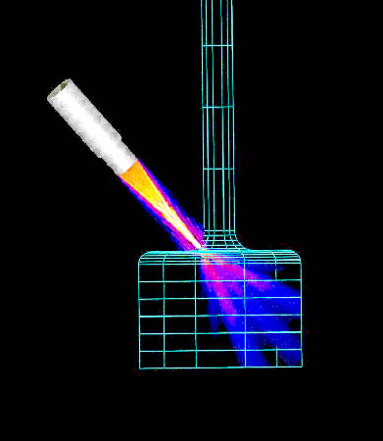
These destructive tests are often used to determine the physical properties of materials such as impact resistance, ductility, yield and ultimate tensile strength, fracture toughness and fatigue strength, but discontinuities and differences in material characteristics are more effectively found by NDT.
Today modern nondestructive tests are used in manufacturing, fabrication and in-service inspections to ensure product integrity and reliability, to control manufacturing processes, lower production costs and to maintain a uniform quality level. During construction, NDT is used to ensure the quality of materials and joining processes during the fabrication and erection phases, and in-service NDT inspections are used to ensure that the products in use continue to have the integrity necessary to ensure their usefulness and the safety of the public.
It should be noted that while the medical field uses many of the same processes, the term "nondestructive testing" is generally not used to describe medical applications.
The use of noninvasive techniques to determine the integrity of a material, component or structure or quantitatively measure some characteristic of an object.
REBOUND HAMMER TEST

This test is also known as the Schmidt hammer or impact hammer, and is a non-destructive method of testing concrete. The test is based on the principle that the rebound of an elastic mass depends on the hardness of the surface against which the mass impinges.

Apparatus:
1-Rebound hammer.
2-Abrasive stone: consisting of medium-grain texture silicon carbide or equivalent
material.

Selection of Test Surface:
Concrete members to be tested shall be at least 100 mm thick and fixed within a structure. Smaller specimens must be rigidly supported. Areas exhibiting honeycombing, scaling, rough texture, or high porosity should be avoided. Concretes should be approximately the same age and moisture condition in order to be compared. Dry concretes give higher rebound numbers than wet concrete, and the surface layer of concrete may be carbonated, yielding higher rebound numbers.

Preparation of test surface:
A test area shall be at least 150 mm in diameter. Heavily textured, soft, or surfaces with loose mortar shall be ground smooth with the abrasive stone. Smooth formed or toweled surface shall be tested without grinding. Concretes over 6 months old may require grinding to a depth of 5 mm if they are to be compared to younger concretes. Grinding to this depth is not feasible without power equipment.

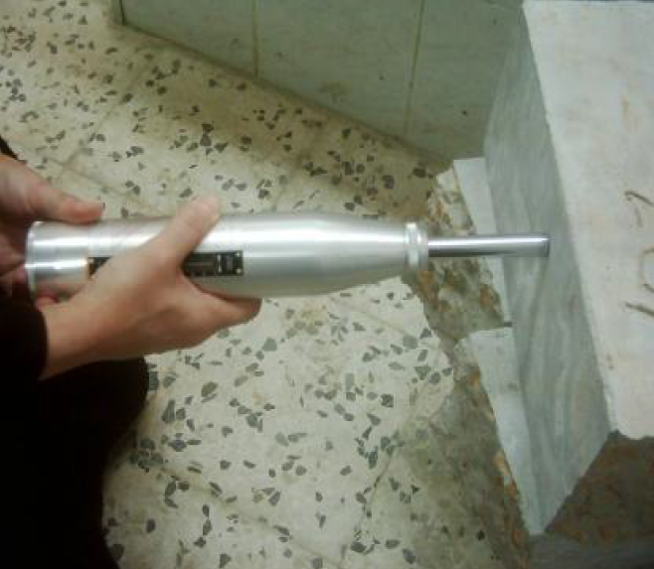
Testing concrete using the Schmidt hammer.
Procedure:
- Firmly hold the instrument in a position that allows the plunger to strike perpendicularly to the surface tested. Gradually increase the pressure on the plunger until the hammer impacts.
- After impact, record the rebound number to two significant figures.
- Take ten readings from each test area. No two impact tests shall be closer together
- than 25 mm.

Calculation:
Discard readings differing from the average of 10 readings by more than 5 units and determine the average of the remaining readings. If more than 2 readings differ from the average by 7 units, discard the entire set of readings.

PULSE VELOCITY THROUGH CONCRETE
This test method covers the determination of the pulse velocity of propagation of compression waves in concrete.The pulse velocity is independent of the dimensions of the body provided reflected waves from the boundaries do not complicate the determination of the arrival time of the directly transmitted pulse.The pulse velocity V is related to the physical properties of a solid by the equation:

V² = (K) (E)/D

Where:
k =a constant
E = the. modulus of elasticity, and
D = the density.
The relationship is independent of the frequency of the vibrations.

Apparatus:
The apparatus used in this test is called “PUNDIT LAB PLUS” . This name is derived from the initial letters of “ Portable Ultrasonic Nondestructive Digital Indicating Tester” and consists of two transducers (54 Khz),two transducer leads,reference bar for checking zero,tin of couplant.

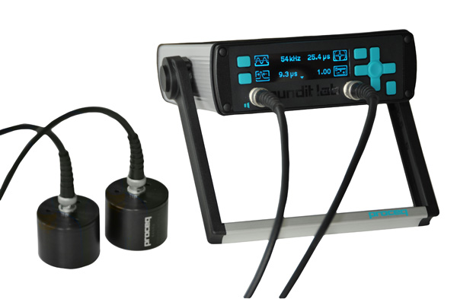

Procedure:
- Before switching on the PUNDIT LAB PLUS, the transducers should be connected to the sockets marked “TRAN” and “REC”.The connection or disconnection of the transmitting transducer should not be made while the instrument switched on.
- The instrument may be operated from either:
i) the internal battery,
ii) an external battery, or
iii) the A.C. mains supply.
- The battery operation is most convenient for field use while the mains operation is generally more suitable for laboratory use.
- If using the A.C. mains supply, plug the mains cable into the 3 way socket mounted on the rear panel, switch the P.S.S. to MAINS and depress the reset button to switch the PUNDIT LAB PLUS ON.
- Before using, it should be calibrated using the reference bar.
- After putting the coupling agent on the transducers faces, the transducers faces are placed and pressed against the reference bar ends, using the “set free button”.
- The reading of the instrument should be adjusted to read the transit time recorded on the calibration bar.
- After applying an appropriate coupling agent (such as water, oil, petroleum jelly, grease, or other viscous materials) to the transducer diaphragms, the test surface, or both, to avoid entrapped air between the contact surface of the diaphragms of the transducers and the surface of the concrete. Press the faces of the transducers against the surfaces of the concrete and measure the transit time.
- Measure the length of the shortest direct path between the centers of the diaphragms.

Calculation:
Calculate the pulse velocity as follows:

V=L/T
Where:

V= pulse velocity, m/s

L= distance between transducers, m

T = effective transmit time, s

TEST ON HIGHWAY MATERIALS

I. ROAD AGGREGATES
1. AGGREGATE CRUSHING / IMPACT VALUE
Exp No: 1 (A) aggregate crushing valuE Date:

Aim:
To find Aggregate Crushing value of the given aggregate sample.
Apparatus:
Steel cylinder, cylindrical measure, Steel tamping rod, Balance, Compression testing machine
THEORY:
The principal mechanical properties required in road stones are: (i) satisfactory resistance to crushing under the roller during construction and (ii) adequate resistance to surface abrasion under traffic. Also surface stresses under rigid tyre rims of heavily loaded animal, drawn vehicles are high enough to consider the crushing strength of road aggregates as an essential requirement in India. Crushing strength of road stones may be determined either on aggregates or on cylindrical specimens cut out of rocks.
Aggregates used in road construction, should be strong enough to resist crushing under traffic wheel loads. If the aggregates are weak, the stability of the pavement structure is likely to be adversely affected. The strength of coarse aggregates is assessed by aggregates crushing test. The aggregate crushing value is a relative measure of resistance to crushing under a gradually applied compressive load. To achieve a high quality of pavement, aggregate possessing low aggregate crushing value should be preferred.
PROCEDURE:
- Take the aggregate passing from 12.5 mm IS sieve and retained on 10 mm sieve.
- Aggregate to be selected should be in surface dry condition before testing.
- Take 6.5 kg of aggregate for preparing two test samples. Then weigh the test sample.
- Then take the cylindrical measure and fill it by the test aggregate sample in three layers of approximately equal depth, tamping each layer 25 times using tamping rod. Each layer depth of material in the cylinder after tamping shall be 10 cm.
- After the third layer is tampered, level the aggregate at the top of the cylindrical measure by using the tamping rod as a straight edge.
- Then place the cylinder with the test sample and plunger in position on the platen of compression testing machine.
- Apply the load through the plunger at a uniform rate of 4 tonnes per minute until the load reaches 40 tonnes and then release the load gradually.
- After the test, remove the cylinder from the machine and sieve the aggregate using 2.36 mm IS sieve and collect the material passing through the sieve.
- For successive trials, take the same weight of the sample and repeat test.
- Take the average of two test values as the average value of aggregate crushing value.
CALCULATION:
Total weight of dry sample taken = W₁ gm.
Weight of the portion of crushed material passing 2.36 mm IS sieve = W₂ gm
Aggregate crushing value = 100 x W₂ / W₁
RESULT:
The mean of the crushing value obtained in the two tests is reported as the aggregate crushing value______________
APPLICATIONS OF AGGREGATE CRUSHING TEST
The aggregate crushing value is an indirect measure of crushing strength of the aggregates. Low aggregate crushing value indicates strong aggregates, as the crushed fraction is low. Thus the test can be used to assess the suitability of aggregates with reference to the crushing strength for various types of pavement components. The aggregates used for the surface course of pavements should be strong enough to withstand the high stresses due to wheel loads, including the steel tyres of loaded bullock-carts. However as the stresses at the base and sub-base courses are low aggregates with lesser crushing strength may be used at the lower layers of the pavement.
Indian Roads Congress and ISI have specified that the aggregate crushing value of the coarse aggregates used for cement pavement at surface should not exceed 30 percent. For aggregates used for concrete other than for wearing surfaces, the aggregate crushing value shall not exceed 45 percent, according to the ISS. However aggregate crushing values have not been specified by the IRC for coarse aggregates to be used in bituminous pavement construction methods.
VIVA VOCE:
  - How is aggregate Crushing value expressed?
  - What is the maximum percentage of crushing value of coarse aggregate used for cement pavement?
  - What is the maximum percentage of crushing value of coarse aggregate used for Cocrete pavement?
  - What are the mechanical properties of coarse aggregates?
  - What is SSD?

SPECIMEN CALCULATIONS

Exp No: 1 (B) AGGREGATE IMPACT VALUE Date:

AIM:
To determine the aggregate impact value of given aggregates

APPARATUS:
Impact testing machine, cylinder, tamping rod, IS Sieve 12.5mm, 10mm and 2.36mm, balance.

THEORY:
The property of material to resist impact is known as toughness. Due to movement of vehicle on the road the aggregates are subjected to impact and there is possibility of stones breaking into smaller pieces. Therefore a test designed to evaluate the toughness of stones i.e., the resistance of the stones to fracture under repeated impacts may be called Impact test on aggregates. The
aggregate impact value is a measure of resistance of sudden impact or shock, which may differ from its resistance to gradually compressive load.
Various agencies have specified the maximum permissible aggregate Impact values for the different types of pavements. IRC has specified the following values. The maximum allowable aggregate Impact value for water bound Macadam; Sub-Base coarse 50% where as cement concrete used in base course is 45%. WBM base course with Bitumen surface in should be 40%. Bituminous Macadam base course should have Aggregate impact value (A.I.V) of 35%. All the surface courses should possess an A.I.V below 30%

PROCEDURE:
The test sample consists of aggregates passing 12.5 mm and retained on 10.0 mm seive. Aggregates may be dried by heating at 100-110° C for a period of 4 hours and cooled.
  - Sieve the material through 12.5 mm and 10.0mm IS sieves. The aggregates passing through 12.5mm sieve and retained on 10.0mm sieve comprises the test material.

  - Pour the aggregates to fill about just 1/3 rd depth of measuring cylinder.
  - Compact the material by giving 25 gentle blows with the rounded end of the tamping rod.
  - Add two more layers in similar manner, so that cylinder is full.
  - Strike off the surplus aggregates.
  - Determine the net weight of the aggregates to the nearest gm (W).
  - Bring the impact machine to rest without wedging or packing up on the level plate, block or floor, so that it is rigid and the hammer guide columns are vertical.

  - Fix the cup firmly in position on the base of machine and place whole of the test sample in it and compact by giving 25 gentle strokes with tamping rod.

  - Raise the hammer until its lower face is 380 mm above the surface of aggregate sample in the cup and allow it to fall freely on the aggregate sample. Give 15 such blows at an interval of not less than one second between successive falls.
  - Remove the crushed aggregate from the cup and sieve it through 2.36 mm IS sieves until no further significant amount passes in one minute. Weigh the fraction passing the sieve to an accuracy of 1 gm. Also, weigh the fraction retained in the sieve.
  - Compute the aggregate impact value. The mean of two observations, rounded to nearest whole number is reported as the Aggregate Impact Value.
OBSERVATIONS & calculationS
Sl.no | Details of Sample | Trial 1 | Trial 2 | Trial 3
1 | Total weight of aggregate sample filling the cylinder measure = W1g
2 | Weight of aggregate passing 2.36mm sieve after the test =W2g
3 | Weight of aggregate retained 2.36mm sieve after the test = W3g
4 | (W1 – W2 + W3)
5 | Aggregate impact value = (W2 / W1)*100 Percent
RESULT:
Aggregate Impact Value = _____________%

RECOMMENDED VALUES

Classification of aggregates using Aggregate Impact Value is as given below:
Aggregate Impact Value | Classification
<20% | Exceptionally Strong
10 – 20% | Strong
20-30% | Satisfactory for road surfacing
>35% | Weak for road surfacing
VIVA VOCE:
1. How is aggregate Impact expressed?
2. What do you understand by dry and wet Impact value?
3. Aggregate Impact value of material A is 15 and that of B is 35. 4. Which one is better for surface course?
REFERENCE:
  - Indian Standard Methods of Test for Aggregate for concrete IS: 2386 Part-IV, Indian Standards Institution.
  - Indian Standard Specifications for Coarse and Fine Aggregate from Natural Sources for Concrete, IS: 383 Indian Standards Institution.
  - S.K. Khann a, C.E.G. Justo, Highway Material Testing Laboratory Manual, Nem Chand & Bros., Roorkee.

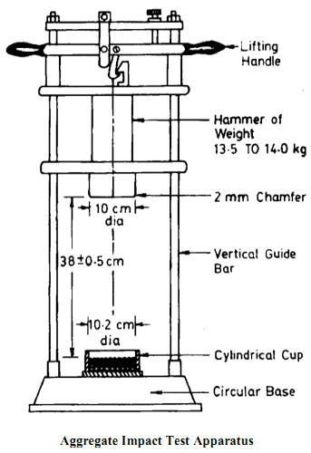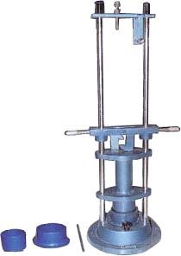
Image showing Aggregate Impact Testing machine

SPECIMEN CALCULATIONS:

2. SPECIFIC GRAVITY AND WATER ABSORPTION

Exp No: 2 (A) SPECIFIC GRAVITY OF COARSE AGGREGATE Date:

AIM:
To determine the specific gravity of given coarse aggregates.

APPARATUS:
10 Kg capacity balance with weights, cylindrical containers of 1litre and 5 litre capacities, measuring jar of 1000 ml capacity.

INTRODUCTION:
The specific gravity of an aggregate is generally required for calculations in connection with cement concrete design work for determination of moisture content and for the calculations of volume yield of concrete. The specific gravity also gives information on the quality and properties of aggregate. The specific gravity of an aggregate is considered to be a measure of strength of quality of the material. Stones having low specific gravity are generally weaker than those with higher specific gravity values.
The bulk density of an aggregate is used for judging its quality by comparison with normal density for that type of aggregate. It is required for converting proportions by weight into proportions by volume and is used in calculating the percentage of voids in the aggregate.
1. Specific gravity is the weight of aggregate relative to the weight of equal volume of water.
2. Void ratio is the ratio of volume of voids to the volume of solids in an aggregate.
3. Percentage of voids or porosity is the ratio of volume of voids to the total volume of a sample of an aggregate.

PROCEDURE:
- Find the weight of the empty container W1.
- Take coarse aggregate in the container up to approximately half of the container and find out the weight W2.
- Fill the container with water up to the level of the coarse aggregates so that all void space inside the aggregate is filled with water. Find its weight W3.
- Fill the container with water after emptying it from mix of coarse aggregate and water.
- Water should be up to the mark, up to which coarse aggregate is filled. Find its weight W4
- Repeat the same process for another trail by taking the aggregate up to the full of the container and by filling the water up to same point.

OBSERVATIONS:

S.NO |  | Trail 1 | Trail 2
1) | Weight of empty container W1
2) | Weight of container with material W2
3) | Weight of container + material + water W3
4) | Weight of container + water W4

Specific gravity = W2 - W1 / ((W4 - W1) - (W3 - W2))

Void ratio = Vol. of Voids / Vol of Solids
=W3 - W1 / ((W4 - W1)-(W3-W2))

Porosity = Vol. of Voids / Total Vol. of aggregate *100
= W3 - W2 / (W4 - W1) * 100

PRECAUTIONS:
While filling the container with water in determining void ratio and porosity of coarse aggregate care should be taken that water should not be in excess of the level of coarse aggregate

RESULT:

1) Specific gravity of coarse aggregate:

2) Void ratio of coarse aggregate:

3) Porosity of coarse aggregate:

VIVA VOCE:
  - Define Specific gravity.
  - Define Porosity.
  - Define void ratio.
  - What is bulk density?

SPECIMEN CALCULATIONS:

Exp No: 2 (B) WATER ABSORPTION OF COARSE AGGREGATE Date:

AIM:
To determine the water absorption of given coarse aggregate

APPARATUS REQUIRED:
Container, Balance, Electric Oven

THEORY:
Water absorption gives an idea of strength of rock. Stones having more water absorption are porous in nature and are generally considered unsuitable unless they are found to be acceptable based on strength, impact and hardness tests.

PROCEDURE:
- Take 200g coarse aggregate passing through 10 mm IS sieve.
- Dry the aggregate in oven at a temperature of 110º ± 5ºC for 24 hours.
- Then cool the coarse aggregate at room temperature.
- Then weigh this aggregate and let its weight be W₁g.
- Immerse the dried coarse aggregate in clean water at a temperature 27º ±2ºC for 24 hours.
- Then remove the coarse aggregate from water and wipe off traces of water with a cloth.
- Then immediately take the weight of coarse aggregate as W₂g.
- Repeat the same procedure for next set of samples.
OBSERVATION AND CALCULATION:

Sample No. | Weight of oven dried specimen (W₁) g | Weight of saturated specimen (W₂) g | Weight of water absorbed  W₃=(W₂-W₁) g |  |  | % of water absorption  =(W₃/W₁) x 100
Weight of dry sample of coarse aggregate W₁ =
Weight of saturated specimen W₂ |  |  |  | =
Weight of water absorbed W = W₂ – W₁  Percentage of water absorption (W₂ – W₁) |  |  |  | =
--------------- x 100 |  |  |  | =
W₁

RESULT:
Water absorption of the coarse aggregate is ____________

VIVA VOCE:
- How does the Water absorption of the coarse aggregate affects the mix design of concrete?

SPECIMEN CALCULATIONS:

3. ATTRITION / ABRASION TEST
Exp No: 3 (A) ABRASION TEST Date:
AIM:
To determine the abrasion value of given aggregate sample by conducting Los Angles abrasion test.
APPARATUS REQUIRED:

Los Angles apparatus, IS Sieve, Weighting Balance.
THEORY:
Due to the movements of traffic, the road stones used in the surfacing course are subjected to wearing actions at the top. When traffic moves on the road the soil particle (sand) which comes between the wheel and road surface causes abrasion on the road stone. Abrasion test are carried out to test the hardness property of stones and to decide whether they are suitable for the different road construction works.
Abrasion tests on aggregates are generally carried out by any one of the following methods.
➢ Los Angeles abrasion test.
➢ Deval abrasion test.
➢ Dorry abrasion test
PRINCIPLE:
The principle of Los Angeles abrasion test is to find the percentage wear due to the relative rubbing action between the aggregates and steel balls used as abrasive charge pounding action of these balls also exist while conducting the test. Maximum Allowable Los Angeles Abrasion Values of Aggregates in Different types of pavement layers as per Indian Road Congress (IRC) are:-For sub-base course a value of 60%. For base course such as WBM, Bituminous Macadam (B.M.), Built – Up spray grout base course and etc. value of 50%. For surface course such as WBM, BM, Bituminous Penetration Macadam, Built-Up spray grout binder course and etc. a value of 40%.
If aggregates are used in surface course as bituminous carpet, bituminous surface dressing, single or two coats, cement concrete surface course and etc. a value of 35%. If aggregates are used for bituminous concrete, Cement concrete pavement as surface coarse than aggregate abrasion value of 30% maximum.
PROCEDURE:
- Take 5kg of clean and dry coarse aggregate conforming to one of the grading A to G and also take 10kg coarse aggregate conforming to one of the grading E, F or G and place in the cylinder. Let the weight of total aggregate is W₁gm.
- Choose the abrasive chargers and place in the cylinder of the abrasion machine, fix the cover and make it dust tight.
- Rotate the machine at a speed of 30 to 33 revolutions per minute.
- Then rotate the machine for 500 revolutions.
- After the desired number of revolutions, then stop the machine and take out the material along aggregate dust from the machine.
- Weigh the coarse aggregate retained on 1.70mm IS sieve as W2 g.

OBSERVATION AND CALCULATIONS:

Sl.No | Details of Sample | Trial 1 | Trial 2 | Average
1 | Weight of sample = W1g
2 | Weight of aggregate retained on  1.70mm IS sieve =W2g
3 | Percentage wear = ((W1 – W2)/W1)*100

RESULT:
The average value of Los Angles Abrasion Test is ________________%

VIVA VOCE:
    - The abrasion value found from Los Angeles test for two aggregates A and B are 50% and 38% respectively. Which aggregate is harder? Why? For what types of constructions are these suitable?
    - Why Los Angeles abrasion test is considered superior to the other form of tests which are used to determine the hardness of aggregates?
    - Two materials have abrasion values 3 and 10 respectively. Which one is harder and why?

Grading Table of Test Sample:

Sieve Size (Square Hole) |  | Weight in gms of test sample for grades
Passing  (mm) | Retained  on (mm) | A | B | C | D | E | F | G
80 | 63 | ---- | ----- | ---- | ---- | 2500 | ---- | ----
63 | 50 | ---- | ---- | ---- | ---- | 2500 | ---- | ----
50 | 40 | ---- | ---- | ---- | ---- | 5000 | 5000 | ----
40 | 25 | 1250 | ---- | ---- | ---- | ---- | 5000 | 5000
25 | 20 | 1250 | ---- | ---- | ---- | ---- | ---- | 5000
20 | 12.5 | 1250 | 2500 | ---- | ---- | ---- | ---- | ----
12.5 | 10 | 1250 | 2500 | ---- | ---- | ---- | ---- | ----
10 | 6.3 | ---- | ----- | 2500 | ---- | ---- | ---- | ----
6.3 | 4.75 | ---- | ---- | 2500 | ---- | ---- | ---- | ----
4.75 | 2.36 | ---- | ---- | ---- | 5000 | ---- | ---- | ----

Selection of Abrasive Charge:

Grading | No of steel balls | Weight of charge, gm
A | 12 | 5000+ 25
B | 11 | 4584+ 25
C | 8 | 3330+ 20
D | 6 | 2500+ 15
E | 12 | 5000+ 25
F | 12 | 5000+ 25
G | 12 | 5000+ 25

REFERENCE:
    - Indian Standard Methods of Test for Aggregate for concrete IS: 2386 Part-IV, Indian Standards Institution.
    - Indian Standard Specifications for Coarse and Fine Aggregate from Natural Sources for Concrete, IS: 383 Indian Standards Institution.
    - S.K. Khanna, C.E.G. Justo, Highway Material Testing Laboratory Manual, Nem Chand & Bros., Roorkee.

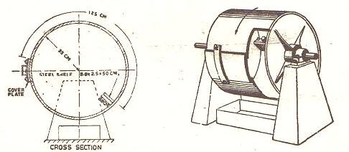

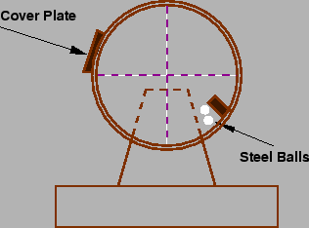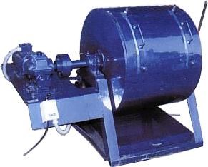
Los Angeles Abrasion Testing Machine
SPECIMEN CALCULATIONS:

4. SHAPE TESTS
Exp No: 4 FLAKINESS & ELONGATION INDEX TEST (SHAPE TEST). (IS: 2386 — PART — 1) Date:
INTRODUCTION:
The particle shape of aggregates is determined by the percentages of flaky and elongated particles contained in it. For base course and construction of bituminous and cement concrete types, the presence of flaky and elongated particles are considered undesirable as they may cause inherent weakness with possibilities of breaking down under heavy loads. The angularity number i.e., flaky and elongation has considerable importance in the gradation requirements of various types of mixes such as bituminous concrete, cement concrete and soil aggregate mixes.
AIM:
To determine the flakiness and elongation of the aggregates by standard flakiness gauge and elongation gauges.
APPARATUS:
a) Flakiness gauge (Thickness gauge): The Flakiness index of aggregates is the percentages by weight of particles whose least dimension is less than three-fifths (0.6) of their mean dimension. The test is not applicable to sizes smaller than 6.3mm. The apparatus consists of a standard thickness gauge of IS sieve sizes 63, 50, 40, 31.5, 25, 20, 16, 12.5, 10 and 6.3mm and a balance to weigh the samples.
b) Elongation gauge (Length gauge): The elongation index of aggregate is the percentage by weight of particles whose greatest dimension (length) is greater than one and four fifth times (1.8) their mean dimension. The elongation test is not applicable to sizes smaller than 6.3mm. The apparatus consists of a standard length gauge of IS sieve sizes 50, 40, 31.5, 25, 20, 16, 12.5, 10 and 6.3mm.
FLAKINESS INDEX: The flakiness index of aggregates is the percentage by particles whose least dimension (thickness) is less than 3/5th (0.6) of their mean dimension. The test is not applicable to sizes smaller than 6.3mm.
ELONGATION INDEX: The elongation index of an aggregate is the percentage by weight of particles whose greatest dimension (length) is greater than 1 and 4/5th times (1.8 times) their mean dimensions. The elongation test is not applicable to sizes smaller than 6.3mm.
PROCEDURE:
Flakiness Index:
- Sieve the sample with IS sieves mentioned in above.
- Take a minimum of 200 pieces of each fraction to be and weigh the sample.
- To Separate the flaky materials, each fraction is then gauged for thickness on a thickness gauge.
- The amount of flaky material passing the gauge is weighed to an accuracy of at least 0.1 percent of the test sample.
CALCULATIONS:
Let the weight of the flaky materials passing the gauge be w1gm. Similarly the weights of the fractions passing and retained on the specified sieves be w1, w2, w3, etc. are weighed and the total weight w1+w2+w3+………. = w g is found. Also the weights of the materials passing each of the specified thickness gauges are found = W1, W2, W3… and the total weight of the material passing the different thickness gauges = W1+W2+W3+……=W g is found.
Then the flakiness index is the total weight of the flaky material passing the various thickness gauges expressed as a percentage of the total weight of the sample gauged.
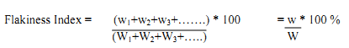
OBSERVATION TABLE:
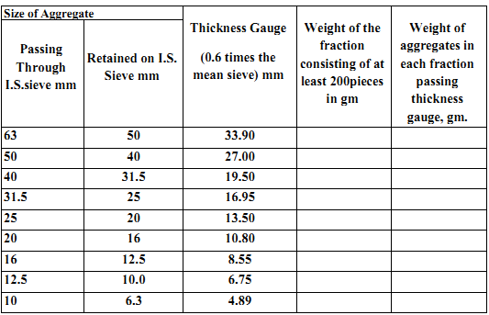

PROCEDURE:
b) Elongation Index:
- The sample is sieved through the IS sieves specified as above. A minimum of 200 pieces of each fraction is taken and weighed. In order to separate elongated material, each fraction is then gauged individually for length in a length gauge.
- The pieces of aggregates from each fraction tested which could not pass through the specified gauge length with its long side are elongated particles and are collected separately to find the total weight of aggregates retained on the length gauge from each fraction.
- The total amount of elongated material retained by the length gauge is weighed to an accuracy of at least 0.1 percent of the weight of the sample.
CALCULATIONS:
The weight of each fraction of aggregate passing and retained on specified sieves sizes are found W1, W2, W3, …………. And the total weight of sample determined = W1+W2+W3+……………. = W g.
Also the weights of material from each fraction retained on the specified gauge length are found = x1, x2, x3… and the total weight retained determined = x1+x2+x3+…… = x gm.
The elongation index is the total weight of the material retained on the various length gauges, expressed as a percentage of the total weight of the sample gauged.
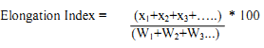
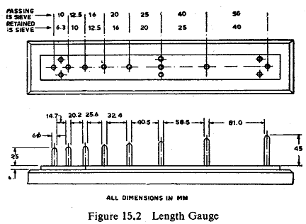
OBSERVATION TABLE:
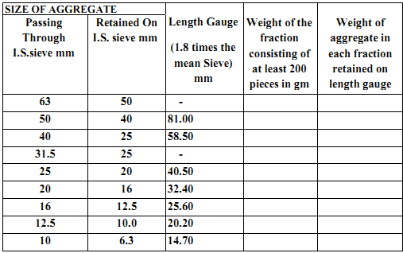
Image of Flakiness index and elongation index test
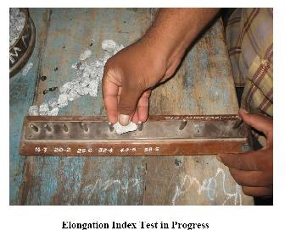

RESULT:

The elongation index and flakiness index of the given sample of aggregates is ___________% and ____________%

VIVA VOCE:
- What do you mean by flakiness index of an aggregate?
- What do you infer from flakiness index?
- How the flakiness index of the sample helps in deciding the design of a highway?

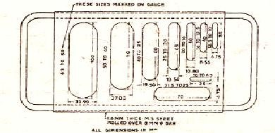
Image of flakiness guage

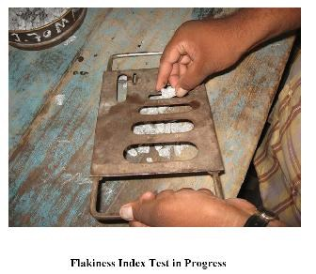

SPECIMEN CALCULATIONS:

II. BITUMINOUS MATERIALS:
5. PENETRATION / SOFTENING POINT TEST
Exp No: 5 (A) penetration of bitumen Date:
AIM:
To determine the penetration of bitumen.
THEORY:
The consistency of bituminous materials varies depending upon several factors such as constituent, temperature etc. at temperature 25 °C to 50 °C most of the paving bitumen grades remains in semi –solid states and their viscosity is so high that they do not flow as liquid. Determination of absolute viscosity of bitumen is not so simple. Therefore the consistency of bitumen is determined by indirect method. Penetration test is one of such type of test.
PRINCIPLE:
This test is done to determine the penetration of bitumen as per IS: 1203-1978. The principle is that the penetration of a bituminous material is the distance in tenths of a mm, that a standard needle would penetrate vertically, into a sample of the material under standard conditions of temperature, load and time.
APPARATUS:
i) Penetrometer
ii) Water bath
iii) Bath thermometer – Range 0 to 44ºC, Graduation 0.2ºC, stop watch
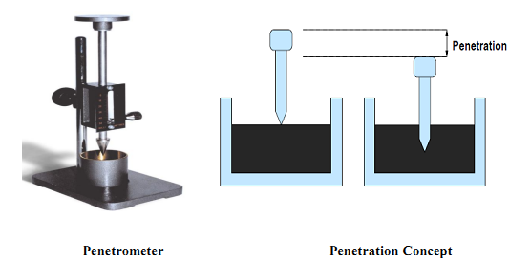
SAMPLE:
Bitumen should be just sufficient to fill the container to a depth of at least 15mm in excess of the expected penetration.
PROCEDURE:
- Soften the bitumen above the softening point (between 75 and 100ºC). Stir it thoroughly to remove air bubbles and water.
- Pour it into a container to a depth of at least 15mm in excess of the expected penetration.
- Cool it at an atmospheric temperature of 15 to 30ºC for 1^{1/2} hours. Then place it in a transfer dish in the water bath at 25.0 + 0.1ºC for 1^{1/2} hrs.
- Keep the container on the stand of the penetration apparatus.
- Adjust the needle to make contact with the surface of the sample.
- Adjust the dial reading to zero.
- With the help of the timer, release the needle for exactly 5 seconds.
- Record the dial reading.
- Repeat the above procedure thrice.
OBSERVATION TABLE:
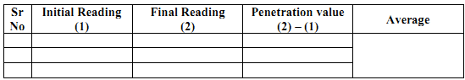
REPORTING OF RESULTS
The value of the penetration report shall be the mean of not less than three determinations whose values do not differ by more than the amount given below:

Penetration grade Maximum differences
0 – 49 2
50 – 149 4
150 – 249 6
250 and above 8
Penetration test is commonly adopted test on bitumen to grade the material in terms of its hardness. 80/100 grade bitumen indicates that its penetration value lies between 80 and 100. The grading of bitumen helps to access its suitability for use in different climatic conditions and types of construction. For bituminous macadam and penetration macadam, IRC suggests bitumen grades 30/40, 60/70, and 80/100. In warmer regions lower penetration grades are preferred to avoid softening whereas higher penetration grades like 80/100 are used in colder regions so that excessive brittleness does not occur. Highest penetration grade is used in spray application works.
RESULT:

The Penetration value of given bitumen is ________________

APPLICATIONS OF PENETRATION TEST:
Penetration test is the most commonly adopted test on bitumen to grade the material in terms of its hardness. Depending upon the climatic condition and type of construction, bitumens of different penetration grades are used. 80/100 bitumen denotes that the penetration value ranges between 80 and 100. The penetration values of various types of bitumen used in pavement construction in this country range between 20 and 225. For bituminous macadam and penetration macadam, Indian Roads Congress suggests bitumen grades 30/40, 60/70 & 80/100. In warmer regions lower penetration grades are preferred and in colder regions bitumen 'with higher penetration values are used.
The penetration test is not intended to estimate the consistency of softer materials like cutback or tar, which are usually graded by a viscosity test in an orifice viscometer.
The Indian Standards Institution has classified paving bitumen available in this country into the following six categories depending on the penetration values. Grades designated ‘A’ (such as A 35) are from Assam Petroleum and those designated 'S' (such as S 35) are from other sources.

VIVA VOCE:

  - What are the applications of penetration test?
  - What do you understand by the term 30/40 bitumen?
  - What are the precautions to be taken while conducting a penetration test?
REFERENCES:
- Indian Standard Method for Tar and Bitumen, Determination of Penetration of Bitumen, IS: 1203, Indian Standards Institution.
- Indian Standard Specification for Paving Bitumen, IS: 73.
- S.K. Khanna and C.E.G Justo, Highway Materials Testing Laboratory Manual, Nem Chand Bros. Roorkee.

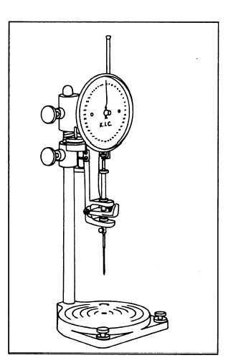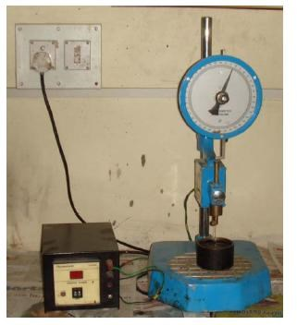
PENETRATION TEST APPARATUS

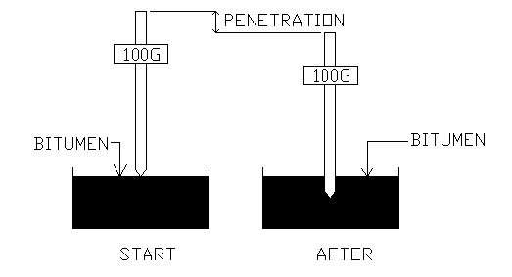
PENETRATION TEST CONCEPT

SPECIMEN CALCULATIONS:

Exp No: 5(B ) SOFTENING POINT TEST OF BITUMINOUS MATERIAL
Date:
AIM:
To determine the softening point of bitumen
THEORY:
Bitumen does not suddenly change from solid to liquid state, but as the temperature increase, it gradually becomes soften until it flows readily. The softening point is the temperature at which the substance attains particular degree of softening under specified condition of test. For bitumen it is usually determined by Ring and Ball apparatus. Higher grades of bitumen possess higher softening point.
This test is done to determine the softening point of asphaltic bitumen and fluxed native asphalt, road tar, coal tar pitch and blown type bitumen as per IS: 1205 -1978. The principle behind this test is that softening point is the temperature at which the substance attains a particular degree of softening under specified condition of the test.
apparatus:
i) Ring and ball apparatus
ii) Thermometer – Low Range: -2 to 80ºC, Graduation 0.2ºC
High Range: 30 to 200ºC, Graduation 0.5ºC
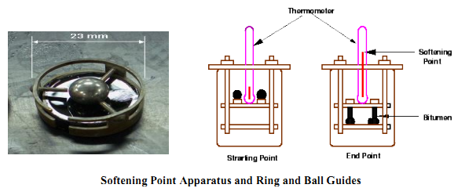

PREPARATION OF SAMPLE
i) The sample should be just sufficient to fill the ring. The excess sample should be cut off by a knife.
ii) Heat the material between 75 and 100ºC. Stir it to remove air bubbles and water, and filter it through IS Sieve 30, if necessary.
iii) Heat the rings and apply glycerine. Fill the material in it and cool it for 30 minutes.
iv) Remove excess material with the help of a warmed, sharp knife.
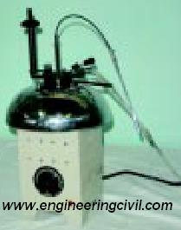
PROCEDURE TO DETERMINE SOFTENING POINT OF BITUMEN
A) Materials of softening point below 80º C:
i) Assemble the apparatus with the rings, thermometer and ball guides in position.
ii) Fill the beaker with boiled distilled water at a temperature 5.0 ± 0.5ºC per minute.
iii) With the help of a stirrer, stir the liquid and apply heat to the beaker at a temperature of 5.0 ± 0.5ºC per minute.
iv) Apply heat until the material softens and allow the ball to pass through the ring.
v) Record the temperature at which the ball touches the bottom, which is nothing but the softening point of that material.
B) Materials of softening point above 80ºC:
The procedure is the same as described above. The only difference is that instead of water, glycerine is used and the starting temperature of the test is 35ºC.
OBSERVATION:
The test result shall not differ from the mean by more than the following:
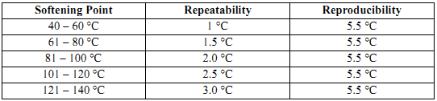
Softening point indicates the temperature at which binder possess the same viscosity. Bituminous materials do not have a definite melting point. Rather the change of state from solid to liquid is gradual and over a wide range of temperature. Softening point has particular significance for materials that are to be used as joint and crack fillers. Higher softening point ensures that they will not flow during service.
In general higher the softening point, the lesser the temperature susceptibility. Bitumen with higher softening point may be preferred in warmer place.
Bitumen grade : _______ Period of air cooling : _______ min
Liquid used in bath : _______ Period of cooling in water bath : _______ min
Rate of heating : _5_ °C/min
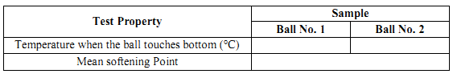
REPORTING OF RESULTS
Record the temperature at which the ball touches the bottom.
RESULT:
The Softening value of given bitumen is ________________
VIVA VOCE:
- What are the factors which affect the ring and ball test results?
- What is softening point?
- If material A has softening point of 56 and B has 42 which binder is good and why?
REFERENCES:

      - Indian Standard Method for Tar and Bitumen, Determination of Softening Point of Bitumen, IS: 1205, Indian Standards Institution.
      - Indian Standard Specification for Paving Bitumen, IS: 73.
      - S.K. Khanna and C.E.G Justo, Highway Materials Testing Laboratory Manual, Nem Chand Bros. Roorkee.

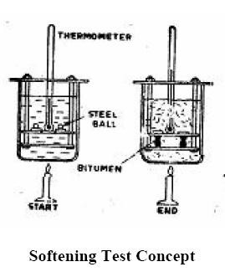

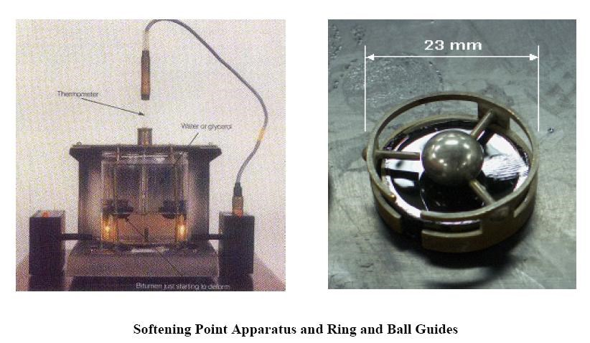

SPECIMEN CALCULATIONS:

6. DUCTILITY / FLASH AND FIRE POINT TESTS

Exp No: 6 (A) DETERMINATION OF DUCTILITY OF THE BITUMEN Date:

AIM:
- To measure the ductility of a given sample of bitumen
- To determine the suitability of bitumen for its use in road construction

APPARATUS:
Briquette mould, (length – 75mm, distance between clips – 30mm, width at mouth of clips – 20mm, cross section at minimum width – 10mm x 10mm), Ductility machine with water bath and a pulling device at a precaliberated rate, a putty knife, thermometer.

THEORY:
A certain minimum ductility is necessary for a bitumen binder. This is because of the temperature changes in bituminous mixes and the repeated deformations that occur in flexible pavements due to the traffic loads. It is of significant importance that the binders form ductile thin films around the aggregates. The binder material which does not possess sufficient ductility would crack and thus provide previous pavement surface. This is in turn results in damaging effect to the pavement structure. The ductility is expressed as the distance in centimeters to which a standard briquette of bitumen can be stretched before the thread breaks.
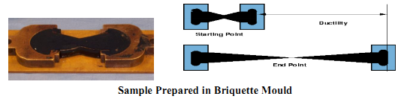
PROCEDURE
Melt the bituminous test material completely at a temperature of 75ºC to 100ºC above the approximate softening point until it becomes thoroughly fluid
    - Strain the fluid through IS sieve 30.
    - After stirring the fluid, pour it in the mould assembly and place it on a brass plate.
    - In order to prevent the material under test from sticking, coat the surface of the plate and interior surface of the sides of the mould with mercury or by a mixture of equal parts of glycerin and dextrin
    - After about 30 – 40 minutes, keep the plate assembly along with the sample in a water bath. Maintain the temperature of the water bath at 27ºC for half an hour.
    - Remove the sample and mould assembly from the water bath and trim the specimen by leveling the surface using a hot knife.
    - Replace the mould assembly in water bath maintained at 27ºC for 80 to 90 minutes
    - Remove the sides of the moulds
    - Hook the clips carefully on the machine without causing any initial strain
    - Adjust the pointer to read zero
    - Start the machine and pull two clips horizontally at a speed of 50mm per minute 12.Note the distance at which the bitumen thread of specimen breaks.
    - Record the observations in the proforma and compute the ductility value.
    - Report the mean of two observations, rounded to nearest whole number as the Ductility Value
OBSERVATIONS:
  - Bitumen grade =
  - Pouring temperature ºC =
  - Test temperature ºC =
  - Periods of cooling, minutes =
        - In air =
        - In water bath before trimming =
        - In water bath after trimming =

 | Sample 1 | Sample 2 | Sample 3
a) Initial reading (a)
b) Final reading (b)
c) Ductility = b-a (cm)
Ductility Value
RESULT:
The Ductility value of given bitumen is ________________
DISCUSSION:
The distance stretched by the moving end of the specimen up to the point of breaking of thread measured in centimeters is recorded as ductility value. It is recommended by ISI that test results should not differ from mean value by more than the following:
Repeatability : 5 percent
Reproducibility: 10 percent
The suitability of bitumen is judged, depending upon its type and proposed use. Bitumen with low ductility value may get cracked especially in cold weather. A certain minimum ductility is necessary for a bitumen binder. This is because of the temperature changes in the bituminous mixes and the repeated deformations that occur in flexible pavements due to the traffic loads. If the bitumen has low ductility value, the bituminous pavement may crack, especially in cold weather. The ductility values of bitumen vary from 5 to over 100. Several agencies have specified the minimum ductility values for various types of bituminous pavement. Often a minimum ductility value of 50 cm is specified for bituminous construction. IS has specified following values of minimum ductility for various grades of bitumen as follows:
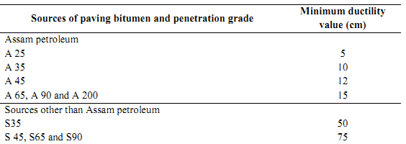
The ductility value gets seriously affected if any of the following factors are varied:
(i) pouring temperature
(ii) dimensions of briquette
(Hi) improper level briquette placement
(iv) test temperature
(v) rate of pulling.
Increase in minimum cross section of 10 sq mm and increase in test temperature would record increased ductility value.
VIVA VOCE:
- List the factors that affect the result of a ductility test.
- What do you understand by the term repeatability and reproducibility?
- Explain the significance of ductility test.
REFERENCES:
- Indian Standard Method for Tar and Bitumen, Determination of Ductility of Bitumen, IS: 1208, Indian Standards Institution.
- Indian Standard Specification for Paving Bitumen, IS: 73.
- S.K. Khanna and C.E.G Justo, Highway Materials Testing Laboratory Manual, Nem Chand Bros. Roorkee.
SPECIMEN CALCULATIONS:

Exp No: 6 (B) FLASH AND FIRE POINT TESTS Date:

AIM:
To determine the flash and fire point of a given bituminous material.
APPARATUS:

Pensky-martens closed cup tester, thermometer, heating source, flame exposure.
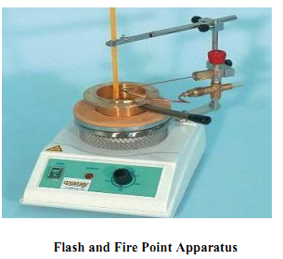
THEORY:
Flash and Fire point test is a safety test conducted on a bituminous material so that it gives an indication of the critical temperature at and above where precautions should be taken to eliminate fire hazards during its applications. Bituminous materials leave out volatiles at high temperature depending upon their grade. These volatile vapors catch fire causing a flash. This condition is very hazardous and it is therefore essential to qualify this temperature for each bitumen grade, so that the paving engineers may restrict the mixing or application temperature well within the limits.
Flash Point: “The flash point of a material is the lowest temperature at which the vapor of substance momentarily takes fire in the form of a flash under specified conditions of test”.
Fire Point: “The fire point is the lowest temperature at which the material gets ignited and burns under specified condition of test”.

Procedure:

A) FLASH POINT
i) Soften the bitumen between 75 and 100ºC. Stir it thoroughly to remove air bubbles and water.
ii) Fill the cup with the material to be tested upto the filling mark. Place it on the bath. Fix the open clip. Insert the thermometer of high or low range as per requirement and also the stirrer, to stir it.
iii) Light the test flame, adjust it. Supply heat at such a rate that the temperature increase, recorded by the thermometer is neither less than 5ºC nor more than 6ºC per minute.
iv) Open flash point is taken as that temperature when a flash first appears at any point on the surface of the material in the cup. Take care that the bluish halo that sometimes surrounds the test flame is not confused with the true flash. Discontinue the stirring during the application of the test
flame.
v) Flash point should be taken as the temperature read on the thermometer at the time the flash occurs.
B) FIRE POINT
i) After flash point, heating should be continued at such a rate that the increase in temperature recorded by the thermometer is neither less than 5ºC nor more than 6ºC per minute.
ii) The test flame should be lighted and adjusted so that it is of the size of a bead 4mm in dia.
OBSERVATION AND CALCULATION:

Bitumen grade: _______
Pouring temperature: _______ °C
Test temperature: _______ °C

Test | Trials |  |  | Mean value
 | 1 | 2 | 3
Flash Point
Fire Point

REPORT:

The flash point shall be taken as the temperature read on the thermometer at the time of the flame application that causes a distinct flash in the interior of the cup. The heating shall be continued until the oil ignites and continues to burn for 5 seconds. The temperature of the material, when this occurs, shall be recorded as the fire point.
The following criteria should be followed for the acceptability of the test results:
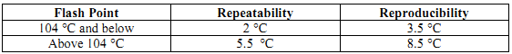
The determination of flash point is helpful in accessing the safe limits of heating the bitumen. The heating temperature of bitumen should be limited well below the flash point.

RESULT:

The temperature at which the flame application that causes a bright flash_______ºC and temperature at which the sample catches fire ____________ºC.
VIVA VOCE:
- Define flash and fire points.
- What is the significance of flash and fire point test?
- What are the parameter that affects the result of flash and fire point tests?
REFERENCES:
- Indian Standard Method for Tar and Bitumen, Determination of Flash and Fire Point of Bitumen, IS: 1209, Indian Standards Institution.
- Indian Standard Specification for Paving Bitumen, IS: 73.
- S.K. Khanna and C.E.G Justo, Highway Materials Testing Laboratory Manual, Nem Chand Bros. Roorkee.

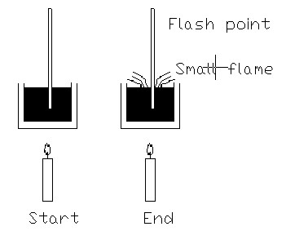

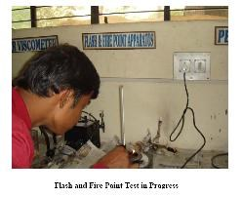

SPECIMEN CALCULATIONS:

